Prakitk 1 : Luar.java

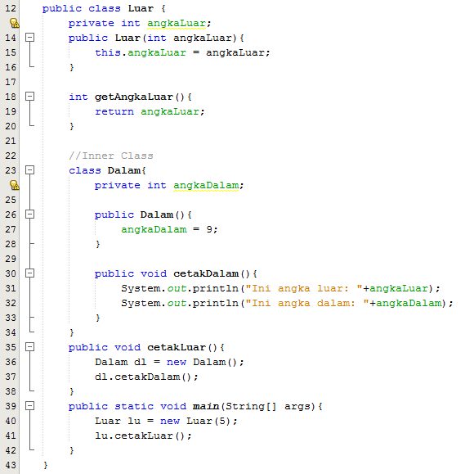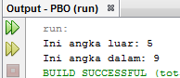

Praktik 2 : RoundShape.java

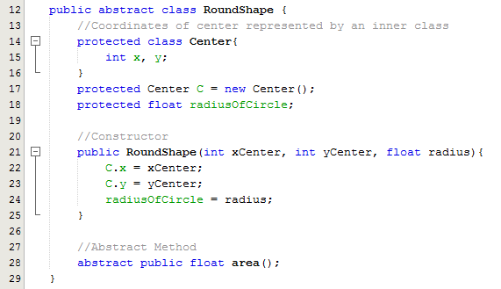

Praktik 3 : Circle.java

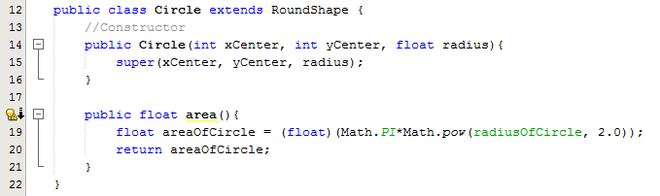

Praktik 4 : Sphere.java

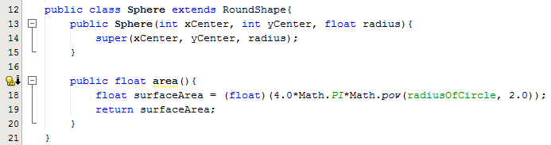

Praktik 5 : TestRoundShape.java

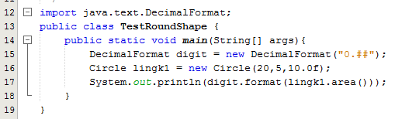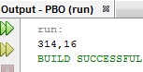

Praktik 6 : TestAnonymous.java

